PRESS INFO.emf**Polymer solutions to improve the efficiency of water systems**

Fluid handling equipment may suffer from multiple problems including physical and mechanical damage as well as general or localized erosion and corrosion. These problems are linked to decreased efficiency and poor performance, leading to increasing operational costs. Minimising performance deterioration is therefore an important factor for pump manufacturers and end users. Indeed, hydraulic losses account for most of the efficiency decrease (9% for a mixed flow pump to 20% for radial flow). Coating technology can help in decreasing these losses, increasing the pump’s performance and reducing operational costs.

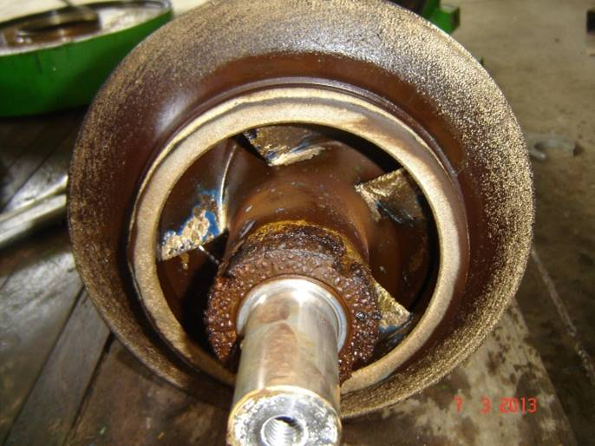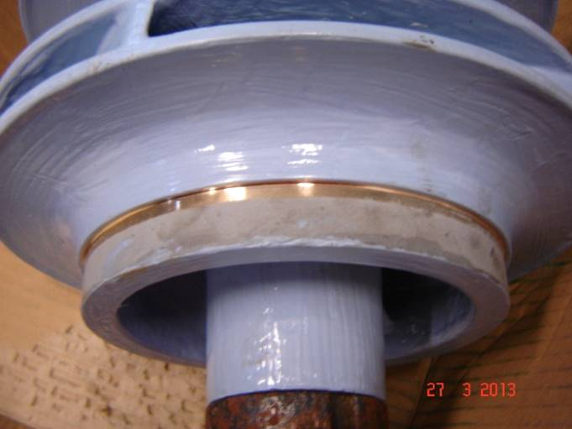  
Pump impeller before application Pump impeller repaired and coated

**Hydrophobic coatings for pump efficiency improvement**

In pumping equipment, it is possible to reduce power consumption and improve the hydraulic properties by changing the pump surface finish. In fact, the loss of efficiency is caused by frictional forces created between the fluid and the walls, the acceleration and the slowing down of the fluid, and the change in the fluid flow direction. The smoother the pump walls, the more fluid turbulence will be reduced, thus reducing the energy required for the pump to move the fluid through the hydraulic passage.

In order to get the best performance possible, pump manufacturers seek to create the smoothest surface possible to reduce the turbulence of the fluid. This can be obtained by the polishing of the selected metal, such as stainless steel; however, this method is extremely time consuming and expensive.

A smooth surface finish can also be obtained by applying an erosion-corrosion resistant efficiency coating on the pump’s volute and impeller. These polymeric coatings are specifically designed to improve efficiency on fluid handling systems and protect metals against the effects of erosion-corrosion. Their unique combination of properties such as self-leveling application, hydrophobicity and hydraulic smoothness makes these coatings ideal candidates for lining the hydraulic passages of pumps. These coatings possess a low electronic affinity towards water molecules and result in a smooth glossy finish once applied onto a metallic surface. This allows the water or other aqueous solutions to easily slide on the surface of the coating.

The smoothness of these hydrophobic epoxy coatings is demonstrated on Graph 1 below, where the surface condition of Belzona 1341 (Supermetaglide), a high performance coating designed to improve efficiency of pumps, pipes, valves and other fluid handling equipment while protecting them from the effects of erosion-corrosion, was measured as fifteen times smoother than polished stainless steel.

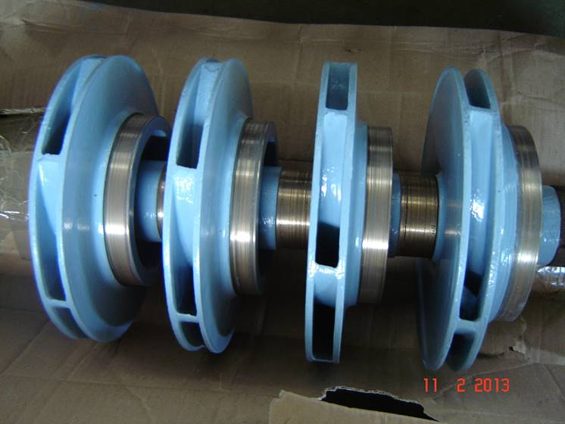  
Belzona 1341 (Supermetalglide) applied

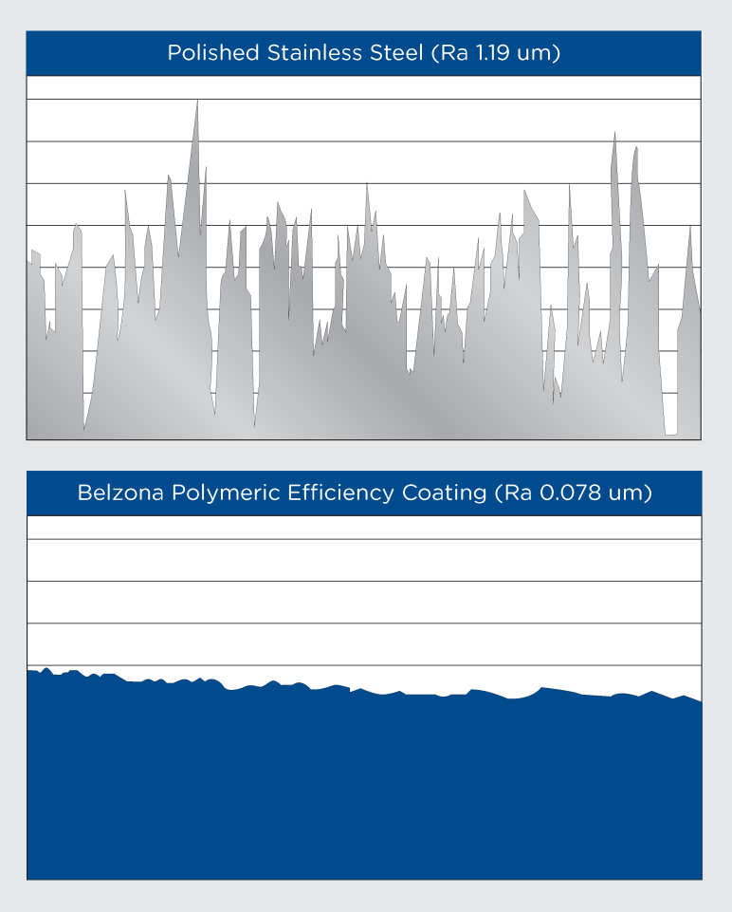

Graph 1: Surface smoothness comparison between polished stainless steel

and Belzona 1341 (Supermetalglide)

As a result of the smoother surface and reduction in flow resistance and friction, the hydraulic performance of the pump can be increased. Graph 2 shows the performance curves of a single stage, end suction centrifugal pump with a 250 mm suction and discharge branches before and after being coated with Belzona 1341. This test was performed by the British National Engineering Laboratories (N.E.L.) and the pump, in uncoated condition and running at 1,300 rpm, was originally found to deliver 875 m3/h at 26.5 meters head and with overall peak efficiency of 83.5% (overall efficiency defined as the ratio of water power output to mechanical power input at the shaft).

Testing of the Belzona 1341 coated pump gave a maximum of 6% increase in the peak efficiency and a reduction in power consumption of 5.1 kWh at duty point. Assuming a 5,000 hours operating cycle/annum, the power savings over this period would amount to 25,500 kWh.

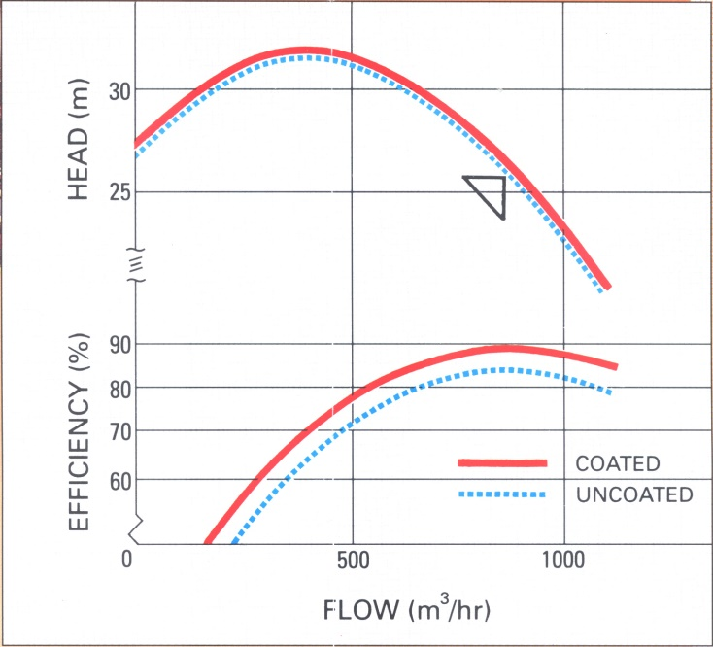

Graph 2: Performance curve of a new pump before and after coating with Belzona 1341

Similar results have been measured by many pump manufacturers around the world, and feedback on industrial equipment protected with this coating show that it is possible to achieve a return in excess of new pump.

**Pump efficiency enhancement with 4 months return of investment**

In 2013, a water elevation plant in Portugal was looking for a solution to improve its hydraulic efficiency. This plant was chosen because of its high energy consumption and costs, with an annual consumption of 1.7 GWh/year and a volume of water propelled of 1.2 Mm3/year recorded in 2012.

The client was looking for a reliable and long-term solution to restore the damaged pump while reducing internal friction in the impeller and volute to enhance hydraulic efficiency. An internal pump coating was chosen to maximize water flow and reduce energy consumption while reducing internal wear and minimize future maintenance actions.

The pump was disassembled and all internal surfaces were grit blasted to remove the previous coating, creating a substrate cleanliness of at least SA2,5 and a surface profile of at least 75μ. The surface was then cleaned and examined to ensure that it was free of dust and other particles.

After grit blasting, the application areas were masked for the application of Belzona 1111 (Super Metal), an epoxy paste grade composite for metal repair. Simply applied using an applicator provided with the product, this material was used to reconstruct the areas damaged by corrosion, rebuilding the original surface profile. This solvent free composite provides excellent corrosion resistance and ensures the substrate is protected when it comes in contact with an abrasive material.

Within the two-hour over coating window, the first coat of Belzona 1341 (Supermetalglide) was applied by brush, followed by a second coat to obtain a total dry film thickness of 500μ. This coating was specified because it provides protection against erosion and long-term corrosion of equipment, whilst improving the efficiency of the pump.

Picture 1: Pump impeller before application Picture 2: Pump impeller repaired and coated

Picture 3: Pump before application Picture 4: Belzona 1341 (Supermetalglide) applied

The main results after coating the pump and changes to the programming of the water elevation plan were:

• Reduced energy consumption during non-peak hours 44.9% to 39.3% (-12.5%)

• Reduced energy consumption by 14.9% (kW / m3), 147,247 KW/h recorded in eight months

• 20.3% cost reduction

• ROI: 4 months of operation

Coated

Graph 3: Energy consumption comparison

m3/h

KW/m3

Graph 4: Power consumption KW / m3 depending on the flow

Notes to Editor-

• Belzona was first established in 1952 in Elland, West Yorkshire before moving to its current Head Office in Harrogate in 1992.

• Belzona is a world leader in the design and manufacture of polymer repair composites and industrial protective coatings for the repair, protection and improvement of machinery, equipment, buildings and structures.

• Belzona is not just a product but a complete service with a global distribution network of over 140 Distributors operating in 120 countries.

• Belzona operates from four corporate offices in Harrogate, UK, Miami, USA, Chonburi, Thailand and Ontario, Canada.

• At Harrogate, the full Belzona product range is manufactured to stringent quality and environmental control guidelines complying with the requirements of ISO 9001:2008 and ISO 14001:2004.